
BandpassModulator VST
Manual for Windows by aquanode (2026)

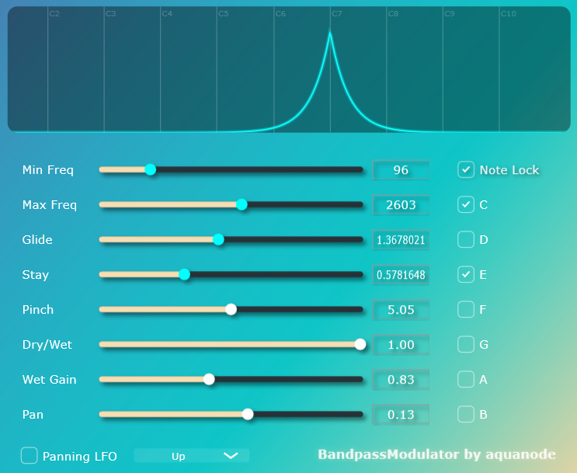

Personal / Copyright Message: This plugin is a passion project for the community. The compiled plugin Is free, and the source code open. Keeping things simple & fair, the rules are as follows:
- Open Source: The source code is available for free, it comes together with the plugin when you download it. To compile from source, you need JUCE and Visual Code. You are welcome to modify the code and use it however you like, but don’t sell it unaltered.
- Official Support: If you don’t want to compile the plugin yourself, you can download it. The only official place to purchase the VST3 file directly is aquanode.gumroad.com for a recommen- ded amount of €3, but feel free to type in 0. Buying there ensures you have the original files and my sincere thanks for your support.
- Sharing is Caring: I don’t track licenses, so you may share the VST with your friends, as long as you do not charge money for it. If you see this plugin being sold anywhere else, it’s a scam.
- No Warranty: I am not responsible for any damages, and when you download the plugin from a third-party website, for malware or viruses. Use such versions at your own risk.
Thank you for your interest in my 1st VST plugin, which I built with JUCE/Visual Code C++.

“BandpassModulator” is, as the name suggests, a rhythmic, musical bandpass filter plugin featuring a unique Note Lock system that keeps filter movements in tune with your track.

It is a VST equivalent of some earlier bandpass filter effects I created in FL Studio’s Patcher and plugdata for example, that are free to download on aquanode.gumroad.com.

Features

- A single state variable filter / bandpass filter that automatically jumps to random frequencies in a predefined frequency window.

- The filter first stays for a duration of “Stay” seconds at a random position, then it takes “Glide” seconds for it to reach a new frequency, where it stays another “Stay” seconds, where “Stay” and “Glide” seconds refer to the value you choose for the respective sliders.

- Stereo Panning of the Filter can be automated as well.

- A Note Lock feature restricts the random filter jumps to frequencies corresponding to certain notes you can choose only.

- Three frequency jumping modes are implemented:

  - Random: The default mode where Stay and Glide behave as described above.

  - Up: The frequency slides upwards, or jumps through the lowest to the highest note if note lock is active.

  - Down: Same as Up, but the jumps are downwards.

Please note that Glide is deactivated for the filter (but not the panning) when Up or Down mode is selected.

- A graphical filter representation, that cycles in color between white and cyan.

How to install
Next to the .vst3 and this pdf, you will find 4 files with endings .h and .cpp in this folder. These make up the complete source code for JUCE, so you can compile and remake the whole effect plugin yourself if you like. Otherwise, you don’t need them.

As I do not own a Mac, only PC / Windows is supported. The plugin was tested on Windows 11 22H2, FL Studio 25, Ableton Live 11, and using Tracktion’s pluginval.
  - Download the zip file and extract it (you did this already).
  - Copy the .vst3 file into your system's VST3 folder. Usually, this is:
C:\Program Files\Common Files\VST3
  - Rescan your DAW’s plugin library (FL Studio, Ableton Live, etc.). The plugin should appear under the "Effects" or "Filter" category.
  - Add it to a mixer track, to which sound is routed.

explanations of the controls

- Min / Max Freq: Sets the frequency range (the "window") in which the bandpass filter operates. When Note Lock is active, the filter will only choose notes within this specific range.
- Stay: Determines the "rhythmic clock" of the plugin. It defines how many seconds the filter remains at a specific frequency before moving to the next one.
- Glide: Controls the transition speed or smoothness between panning and frequencies in Random Mode. In Up/Down Mode, this slider only controls the smoothness of the Panning LFO, while the filter jumps according to the Stay time.
- Width (Resonance): Changes the bandwidth of the filter. Higher values result in a sharper, more resonant "peak" sound, while lower values sound more subtle. Higher values might lead to overdrive, and sharp spikes in volume.
- Panning & Pan LFO: Two modes are possible.
  - Manual Panning: Sets the static stereo position of the filter.
  - Pan LFO Button: When active, the filter moves randomly through the stereo field. The movement is triggered by the "Stay" rhythm but smoothed by the "Glide" time.
- Note Lock & Keyboard: When Note Lock is ON, the filter will only snap to the frequencies of the notes selected on the keyboard (C through B) over all available octaves between the minimum and maximum chosen frequency.
  - In Up/Down Mode, the filter will cycle through these notes in a musical sequence.
- Dry/Wet & Wet Gain:
  - Dry/Wet: Mixes the original signal with the filtered signal.
  - Wet Gain: Allows you to compensate for volume changes caused by narrow filter settings.
Many thanks to Google for their Gemini AI that was indispensable for me to grasp how JUCE and C++ programming even works. It was a real time-saver, as I did not need to become an expert in all the details. The downside to that is of course that I’d still not be able to program a plugin without its help.
Fonts used in this Documentation: Aquatico, Bahnschrift, Conthrax.

